This January, CIMA conducted our third Business and Showcase mission to AmericanaFest UK, normally held in Hackney, London. The two-day conference, awards show and music festival features Americana music from the US, Austria, Spain, Denmark, the UK and more. AmericanaFest UK is keen to build the Canadian presence in the UK which presented a lucrative opportunity for the vast number of Canadian music companies who represent this genre of music in Canada.

During the 2021 virtual edition of AmericanaFest UK, Music Export Canada presented the Canadian Blast showcase. CIMA also partnered with Music PEI to organize two days of one on one meetings between the Canadian artist representatives and the UK industry who attended the virtual showcase. CIMA hired a UK consultant to facilitate the meetings between the UK and Canadian industry and to invite UK industry to the Canadian Blast showcase.

- Canadian Presence: The Canadian Blast showcase featured six Canadian artists who had the opportunity to virtually showcase in front of Americana buyers and industry from the UK. The showcasing artists included: AHI (ON), Carmanah (BC), Julian Taylor (ON), Les Hay Babies (QC), The East Pointers (PEI) and Terra Lightfoot (ON). Canadian companies also had the opportunity to participate in webinars presented by AMAUK throughout the month of February.
- Marketing & Promotion: Specific marketing and promotion initiatives included: press and promotion though the CIMA website, newsletter and social media properties prior to and during the event.
- Outcomes: Participants reported making more than 20 connections through the Canadian Blast showcase with UK delegates. Participants took 25 meetings with UK industry throughout the week which resulted in starting or finalizing 3 deals with a potential revenue of $50,000 over the next 36 months.

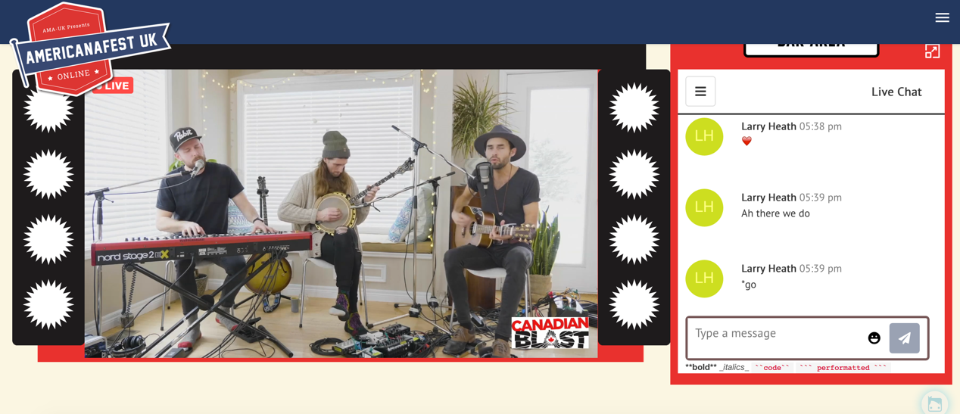
Screenshot of The East Pointers at the Canadian Blast showcase during AMAUK

